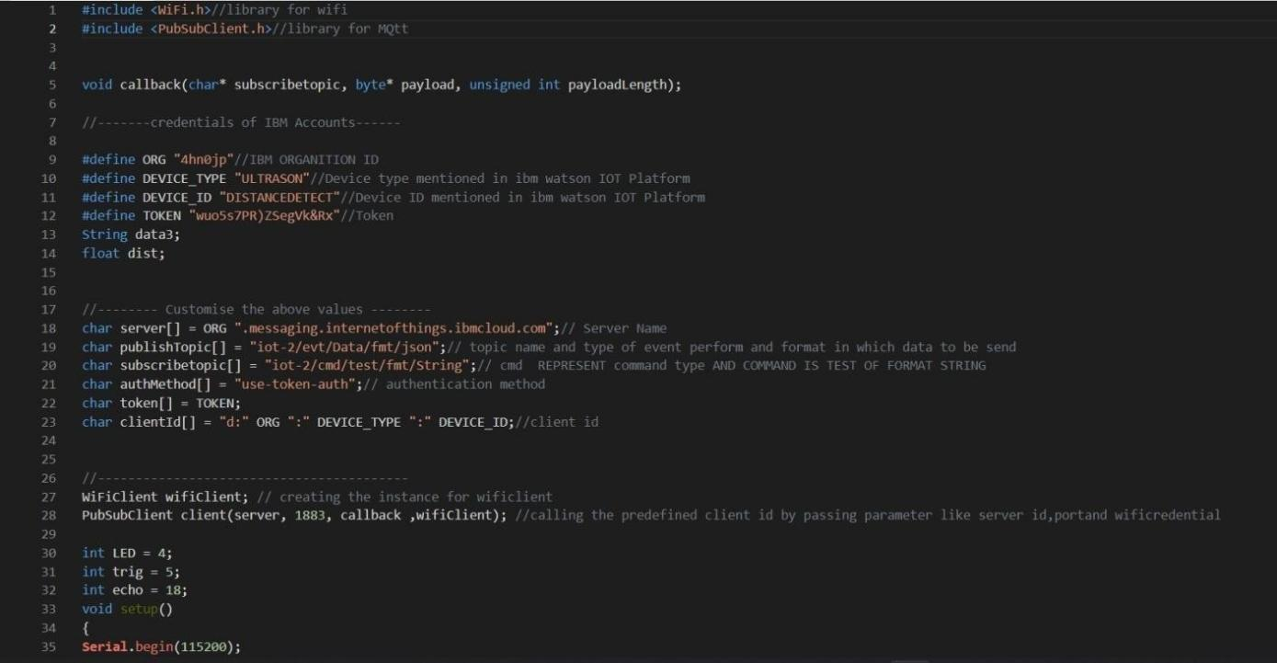

# ASSIGNMENT-4

|  |  |
| --- | --- |
| Date | 28October2022 |
| TeamID | PNT2022TMID12350 |
| Name | VIDHYA S |
| MaximumMarks | 2 Marks |

**Question1:**

Write code and connections in work for ultrasonic sensor.Whenever distance is less than 100cmssend"alert"toibmcloudanddisplayindevicerecentevents.

**CODE**:

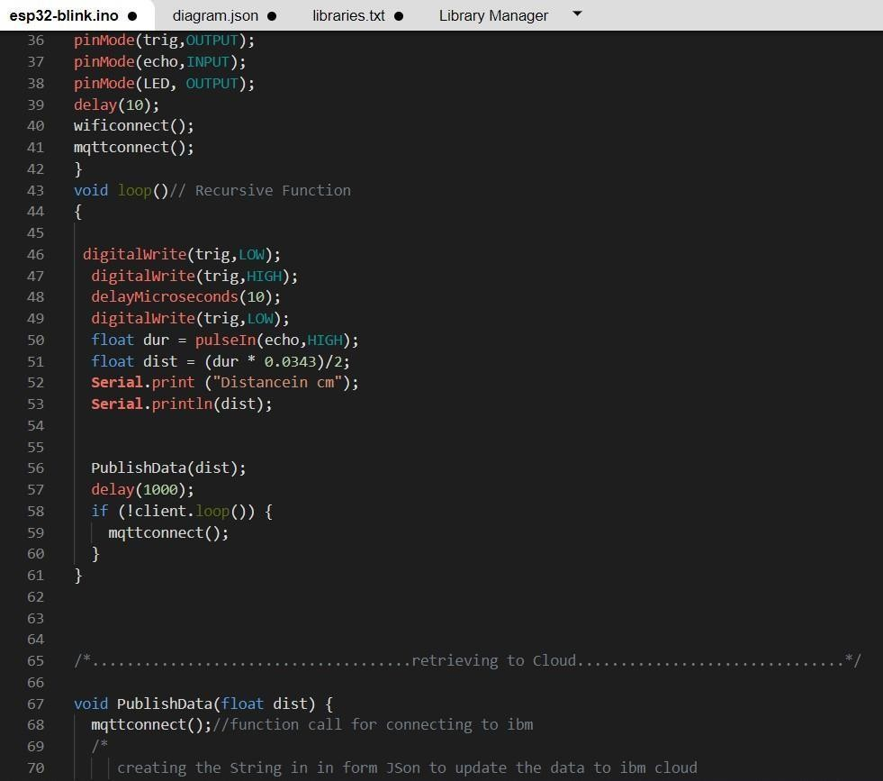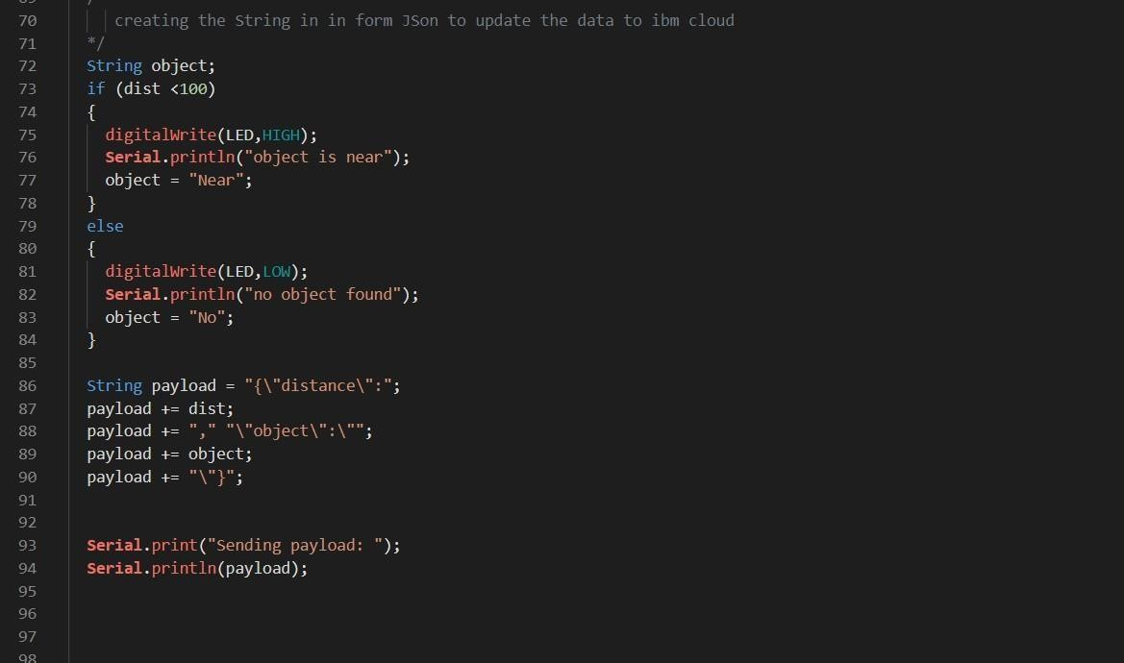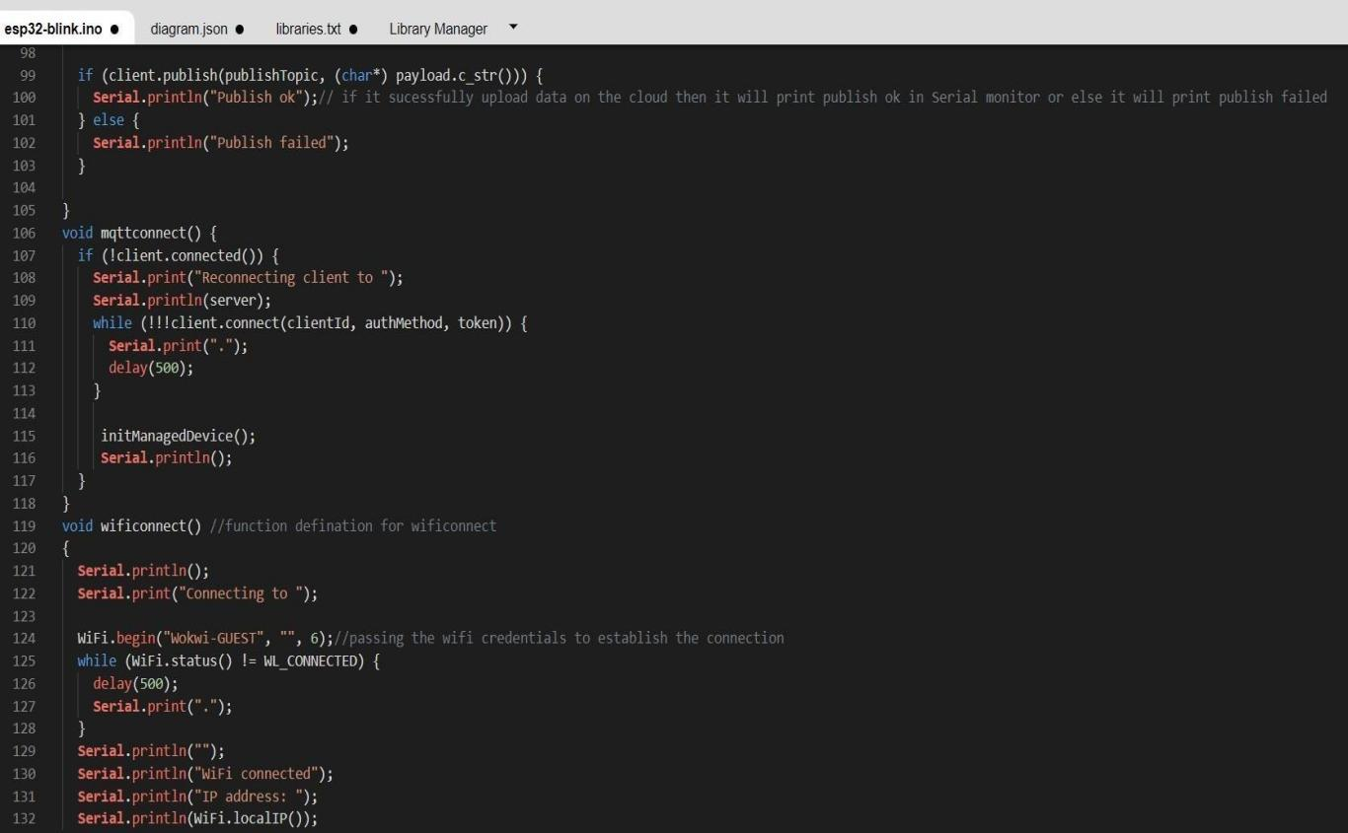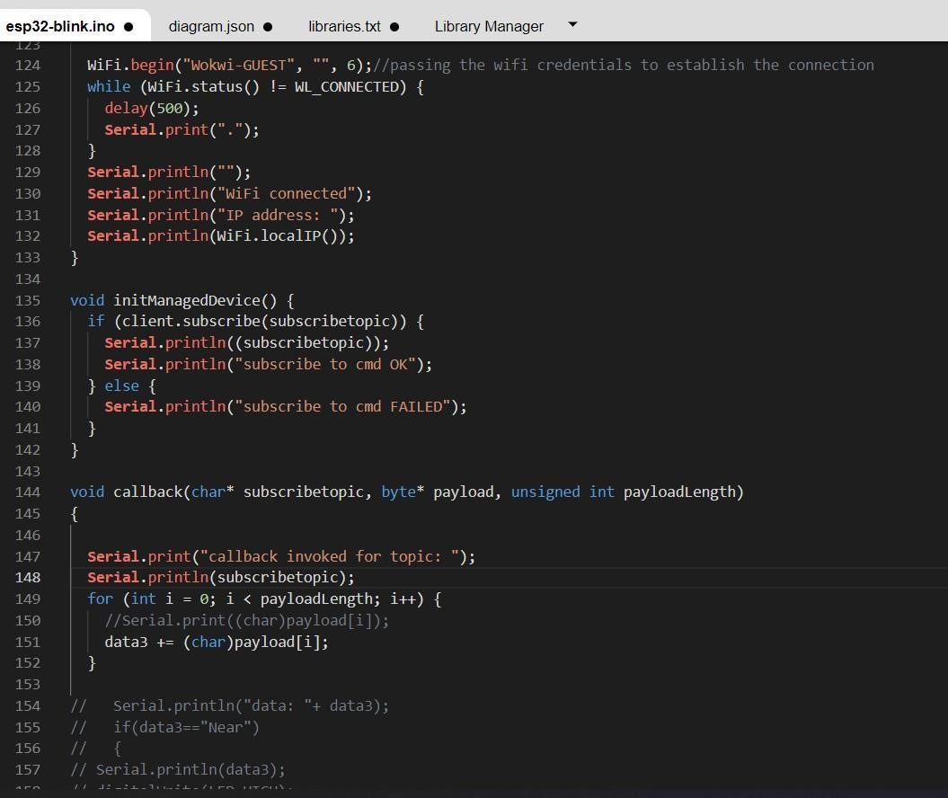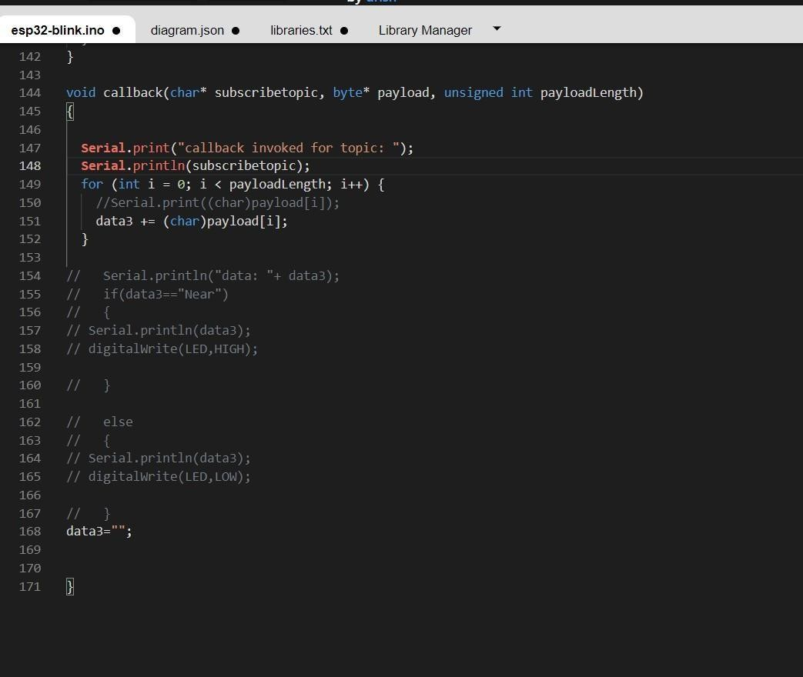

# OUTPUT:

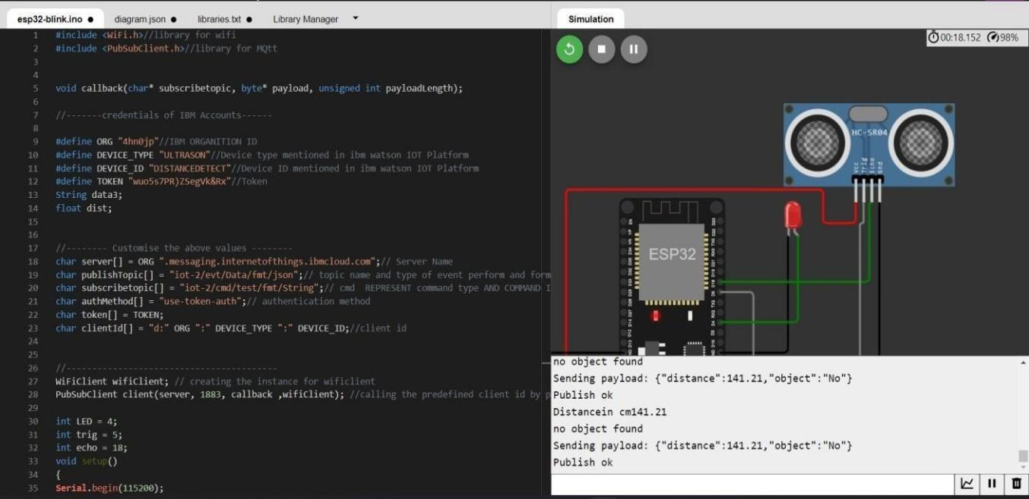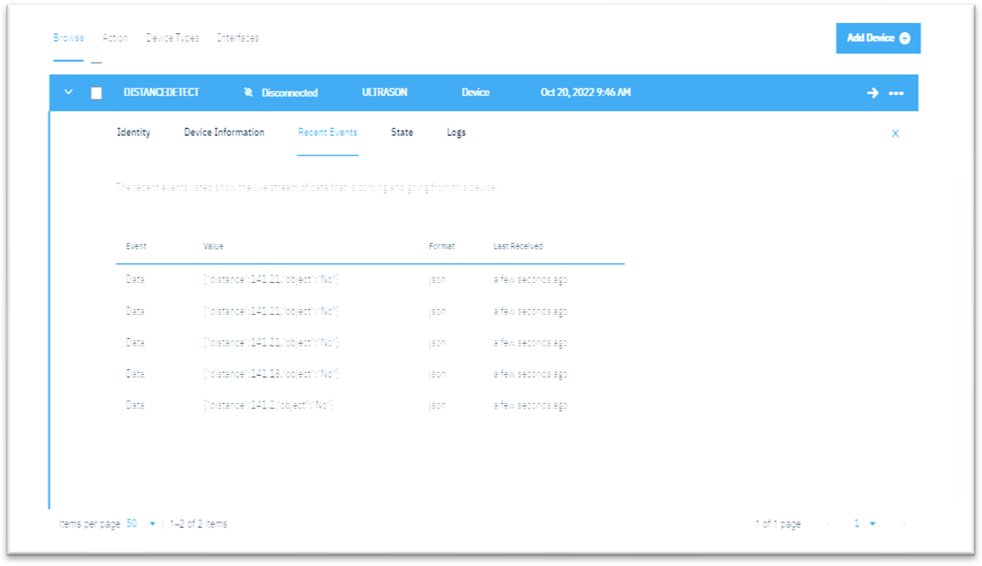

## DatasendtotheIBMclouddevicewhentheobjecticsfar

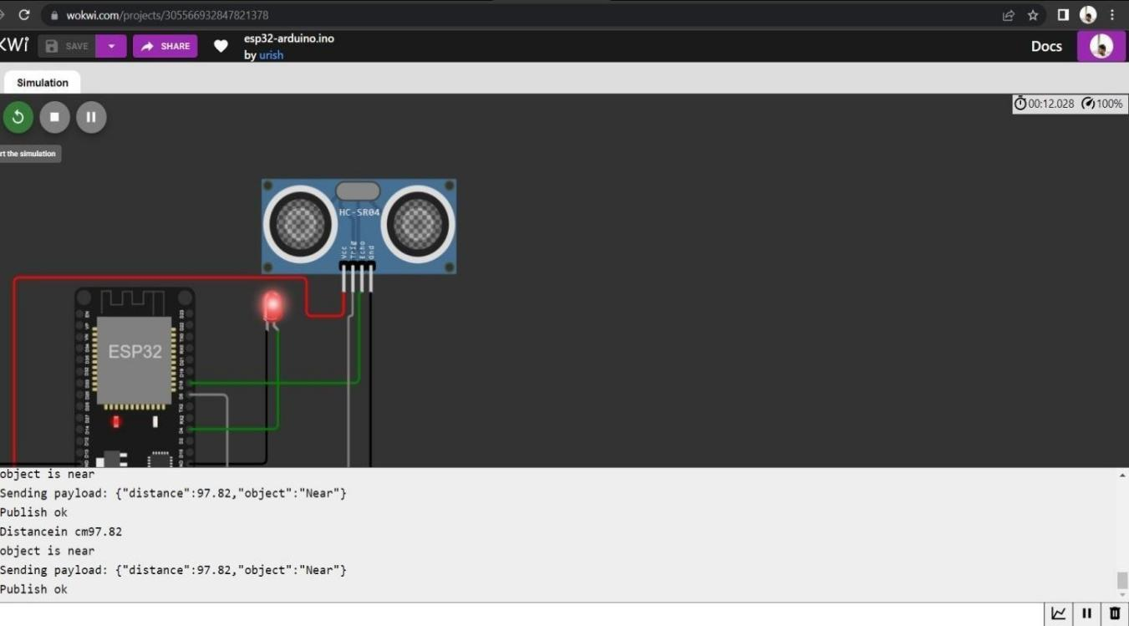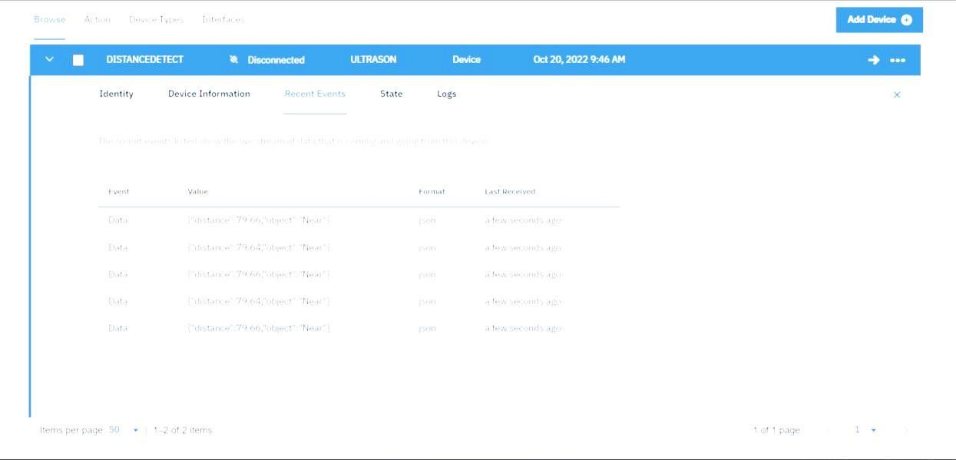

DatasenttotheIBMCloudDevicewhentheobjectisnear

## Whenobjecticsneartotheultrasonicsensor